**Московский Государственный Технический Университет им. Н.Э. Баумана**

**Разработка интернет-приложений**

Отчёт по лабораторной работе №6

«Работа с СУБД»

Выполнил:

студент группы ИУ5-54

Тарасов Д.П.

1. Цель работы

Подключить СУБД к приложению Djando

2. Листинг

Файл settings.py — настройка баз данных

DATABASES = {

**'default'**: {

**'ENGINE'**: **'django.db.backends.mysql'**,

**'OPTIONS'**: {

**'db'**: **'grow_db'**,

**'read_default_file'**: **'~/.my.cnf'**

}

}

}

Модуль grow/connection.py

**import** MySQLdb

**class** Connection:

**def** __init__(self, host, db_name, read_default_file=**"~/.my.cnf"**):

self.host = host

self.db_name = db_name

self.read_default_file = read_default_file

self._connection = None

@property

**def** connection(self):

**return** self._connection

**def** __enter__(self):

**return** self.connect()

**def** __exit__(self, exc_type, exc_val, exc_tb):

self.disconnect()

**def** connect(self):

**if not** self._connection:

self._connection = MySQLdb.connect(

host=self.host,

db=self.db_name,

read_default_file=self.read_default_file

)

**return** self.connection

**def** disconnect(self):

**if** self._connection:

self._connection.close()

Модуль connect.py – проверка подключения к БД

**import** MySQLdb

**from** MySQLdb.constants **import** FIELD_TYPE

db = MySQLdb.connect(host=**"localhost"**, db=**"grow_db"**, read_default_file=**"~/.my.cnf"**)

cursor=db.cursor()

cursor.execute(**"select article_id, author_id, pubdate, likes from articles"**)

result = cursor.fetchall()

**for** x **in** result:

**print**(x)

Модуль db_models.py – модели с возможностью сохранения в базу

**import** connection

**class** Author:

**def** __init__(self, first_name, last_name, about, email, phone_number):

self.connection = connection.Connection(host=**"localhost"**, db_name=**"grow_db"**)

self.first_name = first_name

self.last_name = last_name

self.about = about

self.email = email

self.phone_number = phone_number

**def** save(self):

**with** self.connection **as** c:

cursor = c.cursor()

cursor.execute(**"""insert into grow_author (firstName, lastName, about, email, phone_number)**

**values (%s, %s, %s, %s, %s)"""**, (self.first_name,

self.last_name,

self.about,

self.email,

self.phone_number) )

c.commit()

author = Author(**"Alex"**, **"Klein"**, **"Photographer, traveller"**, **"alex@klein.com"**, **"467214"**)

author.save()

Модуль lab5/urls.py

**from** django.conf.urls **import** include, url  
**from** django.contrib **import** admin  
  
urlpatterns = [  
 url(**r'^articles/'**, include(**'grow.urls'**)),  
 url(**r'^admin/'**, admin.site.urls)  
]

Модуль grow/urls.py

**from** django.conf.urls **import** url  
  
**from** . **import** views  
  
urlpatterns = [  
 url(**r'^$'**, views.index, name=**'index'**),  
 url(**r'^(?P<id>(\d+))$'**, views.article, name=**'article'**)  
]

Модуль grow/views.py

**from** django.shortcuts **import** render  
**from** django.shortcuts **import** render_to_response  
**from** django.template.loader **import** render_to_string  
**from** django.http **import** HttpResponse  
**from** django.template **import** RequestContext, loader  
**from** .models **import** Article  
  
*# Create your views here..***def** index(request):  
 articles = Article.objects.all()  
 content = {  
 **'articles'**: articles  
 }  
 **return** render(request, **'articles.html'**, content)  
  
  
**def** article(request, id):  
 art = Article.objects.get(id=int(id))  
 content = {  
 **'article'** : art  
 }  
 **return** render(request, **'single.html'**, content)

Модуль grow/models.py

**from** django.db **import** models  
  
  
*# Create your models here.***class** Article(models.Model):  
 title = models.CharField(max_length=100)  
 author = models.ForeignKey(**"Author"**)  
 content = models.TextField()  
 snippet = models.CharField(max_length=500)  
 pubdate = models.DateTimeField()  
 likes = models.PositiveIntegerField()  
  
 **def** __unicode__(self):  
 **return** self.title  
  
  
**class** Author(models.Model):  
 firstName = models.CharField(max_length=50)  
 lastName = models.CharField(max_length=50)  
 about = models.TextField()  
 email = models.EmailField()  
 phone_number = models.CharField(max_length=12)  
 **pass**

Шаблон base.html

<!DOCTYPE **html**>  
<**html lang="en"**>  
  
<**head**>  
 <**title**>Articles on personal growth, entrepreneurship and psychology</**title**>  
  
 <**meta charset="utf-8"**>  
 <**meta name="viewport" content="width=device-width, initial-scale=1, shrink-to-fit=no"**>  
  
 <**link rel="stylesheet" href="https://maxcdn.bootstrapcdn.com/bootstrap/4.0.0-beta/css/bootstrap.min.css" integrity="sha384-/Y6pD6FV/Vv2HJnA6t+vslU6fwYXjCFtcEpHbNJ0lyAFsXTsjBbfaDjzALeQsN6M"  
 crossorigin="anonymous"**>  
 {% load static %}  
 <**link rel="stylesheet" type="text/css" href="{% static 'css/style.css' %}"**>  
</**head**>  
  
<**body**>  
 <**div class="container-fluid menu"**>  
 <**div class="row"**>  
 <**h1 class="col-md-2"**> GROW </**h1**>  
 <**div class="col-md-5"**></**div**>  
 <**div class="col-md-2 menu-button"**>  
 <**a href="/articles/"**><**p**>ARTICLES</**p**></**a**>  
 </**div**>  
 <**div class="col-md-2 menu-button"**>  
 <**a href="#"**><**p**>AUTHORS</**p**></**a**>  
 </**div**>  
 </**div**>  
 </**div**>  
  
 <**div class="content"**>  
 {% block content %} {% endblock %}  
 </**div**>  
  
  
 <**script src="https://code.jquery.com/jquery-3.2.1.slim.min.js" integrity="sha384-KJ3o2DKtIkvYIK3UENzmM7KCkRr/rE9/Qpg6aAZGJwFDMVNA/GpGFF93hXpG5KkN"  
 crossorigin="anonymous"**></**script**>  
 <**script src="https://cdnjs.cloudflare.com/ajax/libs/popper.js/1.11.0/umd/popper.min.js" integrity="sha384-b/U6ypiBEHpOf/4+1nzFpr53nxSS+GLCkfwBdFNTxtclqqenISfwAzpKaMNFNmj4"  
 crossorigin="anonymous"**></**script**>  
 <**script src="https://maxcdn.bootstrapcdn.com/bootstrap/4.0.0-beta/js/bootstrap.min.js" integrity="sha384-h0AbiXch4ZDo7tp9hKZ4TsHbi047NrKGLO3SEJAg45jXxnGIfYzk4Si90RDIqNm1"  
 crossorigin="anonymous"**></**script**>  
</**body**>  
  
</**html**>

Шаблон articles.html

{% extends 'base.html' %}  
  
{% block content %}  
  
 {% for article in articles %}  
 <**div class="article-body"**>  
 <**h2**><**a href="/articles/{{article.id}}" target="_blank"**>{{article.title}}</**a**></**h2**>  
 <**p**>{{article.snippet}}</**p**>  
 </**div**>  
 {% endfor %}  
{% endblock %}

Шаблон single.html

{% extends 'base.html' %}  
  
{% block content %}  
  
 <**div class="article-body"**>  
 <**h2**>{{article.title}}</**h2**>  
 <**p**>{{article.content}}</**p**>  
 </**div**>  
  
{% endblock %}

3. Результат

Страница со статьями из базы данных:

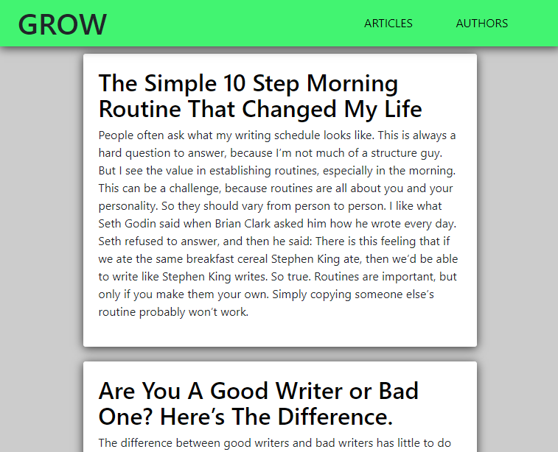

Статья, открытая по клику на название:

